SSMS Tips and Hints:

How to increase the font style for SSMS

For presentation and sharing the screen for group discussions you may consider the following steps to increasing the font style under **SSMS** -> **Tools** -> **Options.**

**You may consider crease either the text editor:**

**However do consider increasing the results grid for better presentations now we are collaborating more online.**

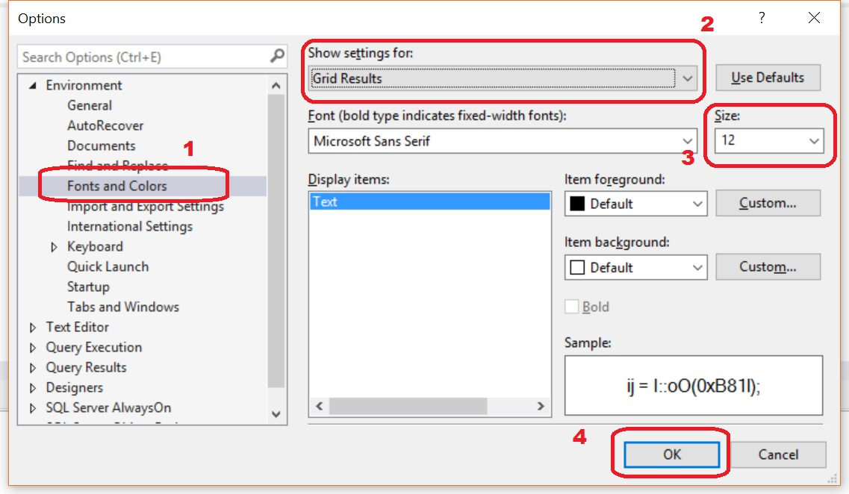

Once you have the options, make sure to select “**Fonts and Colors**” -> Inside the Show settings for: Select -> “**Grid Results**”. Choose the font size you are comfortable. At this moment, please go through the complete list of items that can be customized – you will find some of these really useful.

Some of these settings don’t take immediate effect.

You may need to close the **SSMS** window and reinitialize the same. It would take effect from the next time you open SSMS.

Check your Results Grid output to make sure the font is set at a more legible setting.

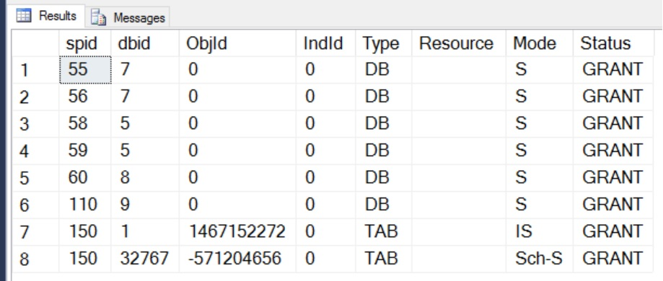

Make sure any future SQL Presentations are clearly legible.

You do not need to go back and redo any prior work. Just a Tip and Hint for next time.